**Name:Gaurav Kishor Patil**

**Roll No:54 Batch:C**

**Div:2**

|  |
| --- |
| Experiment No. 4 |
| Realize half Subtractor and full subtractor |
| Date of Performance:16/08/23 |
| Date of Submission:23/08/23 |

**Aim -** To realize half subtractor and full subtractor

# Objective -

1. The objective of this experiment is to understand the function of Half-adder, Full-adder, Half-subtractor and Full-subtractor.
2. Understand how to implement Adder and Subtractor using logic gates.

# Components required -

1. IC’s - 7486(X-OR), 7432(OR), 7408(AND), 7404 (NOT)

1. Bread Board
2. Connecting wires.

# Theory -

Half adder is a combinational logic circuit with two inputs and two outputs. The half adder circuit is designed to add two single bit binary numbers A and B. It is the basic building block for addition of two single bit numbers. This circuit has two outputs CARRY and SUM.

Sum =A ⊕ B Carry = A B

Full adder is a combinational logic circuit with three inputs and two outputs. Full adder is developed to overcome the drawback of HALF ADDER circuit. It can add two one bit umbers A and B. The full adder has three inputs A, B, and CARRY in,the circuit has two outputs CARRY out and SUM.

Sum = (A⊕B) ⊕ Cin Carry = AB + Cin (A⊕B)

Subtracting a single-bit binary value B from another A (i.e. A -B) produces a difference bit D and a borrow out bit B-out. This operation is called half subtraction and the circuit to realize it is called a half subtractor. The Boolean functions describing the half- Subtractor are

Sum =A ⊕B Carry = A’ B

Subtracting two single-bit binary values, B, Cin from a single-bit value A produces a difference bit D and a borrow out Br bit. This is called full subtraction. The Boolean functions describing the full-subtractor are

Difference = (A ⊕ B) ⊕Cin Borrow = A’B + A’(Cin) + B(Cin)

# Circuit Diagram and Truth Table - Half-adder

**Full-adder**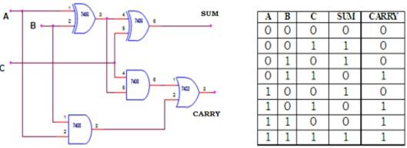

# Half-subtractor

**Full-subtractor**

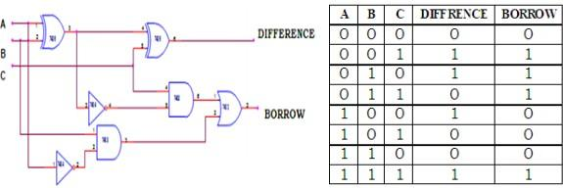

# Procedure -

1. Verify the gates.
2. Make the connections as per the circuit diagram.
3. Switch on VCC and apply various combinations of input according to truth table.
4. Note down the output readings for half/full adder and half/full subtractor, Sum/difference and the carry/borrow bit for different combinations of inputs verify their truth tables.

# Conclusion -

Adder and Subtractor circuits are digital circuits that perform the addition and subtraction of two binary numbers, respectively. These circuits can be implemented using basic logic gates such as AND, OR, and NOT gates. A half-adder is a combinational logic circuit that adds two single bits and produces a sum bit and a carry bit. A full-adder is a combinational logic circuit that adds three single bits and produces a sum bit and a carry bit. A half-subtractor is a combinational logic circuit that subtracts two single bits and produces a difference bit and a borrow bit. A full-subtractor is a combinational logic circuit that subtracts three single bits and produces a difference bit and a borrow bit. These circuits can be implemented using basic gates such as AND, OR, and NOT gates or using universal gates such as NAND or NOR gates